



**Intellectual Property Management Plan**

**February 28, 2011**

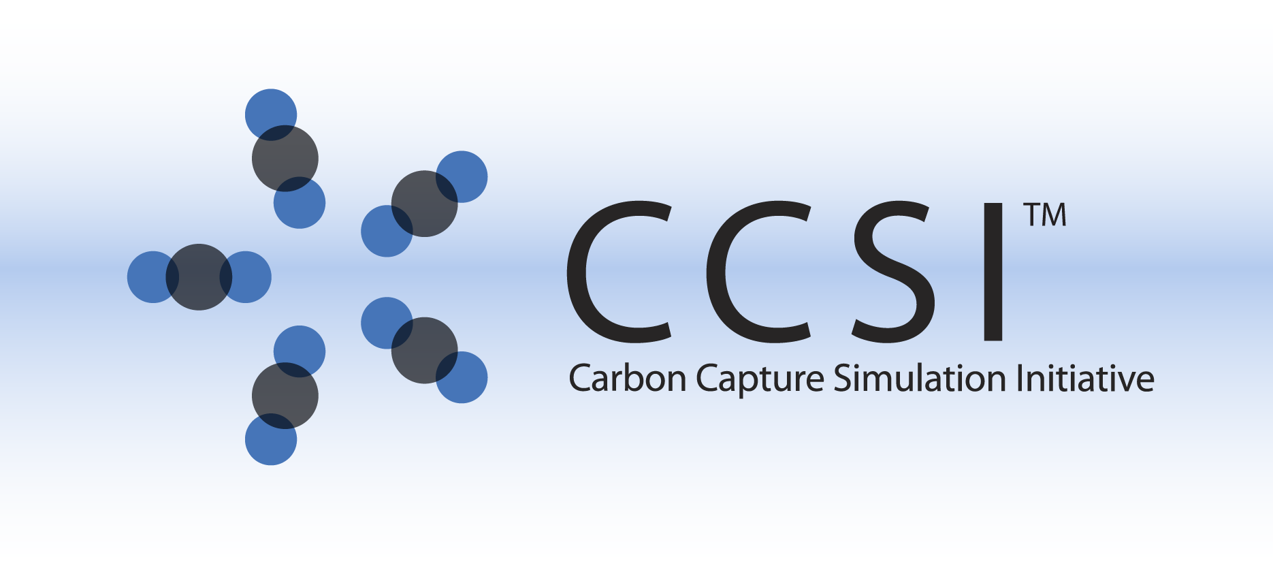

Boiler Model  
User Manual

Version 2.0.0

March 2018

Copyright (c) 2012 - 2018

**Copyright Notice**

Boiler Model was produced under the DOE Carbon Capture Simulation Initiative (CCSI), and is copyright (c) 2012 - 2018 by the software owners: Oak Ridge Institute for Science and Education (ORISE), Los Alamos National Security, LLC., Lawrence Livermore National Security, LLC., The Regents of the University of California, through Lawrence Berkeley National Laboratory, Battelle Memorial Institute, Pacific Northwest Division through Pacific Northwest National Laboratory, Carnegie Mellon University, West Virginia University, Boston University, the Trustees of Princeton University, The University of Texas at Austin, URS Energy & Construction, Inc., et al.. All rights reserved.

NOTICE. This Software was developed under funding from the U.S. Department of Energy and the U.S. Government consequently retains certain rights. As such, the U.S. Government has been granted for itself and others acting on its behalf a paid-up, nonexclusive, irrevocable, worldwide license in the Software to reproduce, distribute copies to the public, prepare derivative works, and perform publicly and display publicly, and to permit other to do so.

**License Agreement**

Boiler Model Copyright (c) 2012 - 2018, by the software owners: Oak Ridge Institute for Science and Education (ORISE), Los Alamos National Security, LLC., Lawrence Livermore National Security, LLC., The Regents of the University of California, through Lawrence Berkeley National Laboratory, Battelle Memorial Institute, Pacific Northwest Division through Pacific Northwest National Laboratory, Carnegie Mellon University, West Virginia University, Boston University, the Trustees of Princeton University, The University of Texas at Austin, URS Energy & Construction, Inc., et al. All rights reserved.

Redistribution and use in source and binary forms, with or without modification, are permitted provided that the following conditions are met:

1. Redistributions of source code must retain the above copyright notice, this list of conditions and the following disclaimer.
2. Redistributions in binary form must reproduce the above copyright notice, this list of conditions and the following disclaimer in the documentation and/or other materials provided with the distribution.
3. Neither the name of the Carbon Capture Simulation Initiative, U.S. Dept. of Energy, the National Energy Technology Laboratory, Oak Ridge Institute for Science and Education (ORISE), Los Alamos National Security, LLC., Lawrence Livermore National Security, LLC., the University of California, Lawrence Berkeley National Laboratory, Battelle Memorial Institute, Pacific Northwest National Laboratory, Carnegie Mellon University, West Virginia University, Boston University, the Trustees of Princeton University, the University of Texas at Austin, URS Energy & Construction, Inc., nor the names of its contributors may be used to endorse or promote products derived from this software without specific prior written permission.

THIS SOFTWARE IS PROVIDED BY THE COPYRIGHT HOLDERS AND CONTRIBUTORS "AS IS" AND ANY EXPRESS OR IMPLIED WARRANTIES, INCLUDING, BUT NOT LIMITED TO, THE IMPLIED WARRANTIES OF MERCHANTABILITY AND FITNESS FOR A PARTICULAR PURPOSE ARE DISCLAIMED. IN NO EVENT SHALL THE COPYRIGHT OWNER OR CONTRIBUTORS BE LIABLE FOR ANY DIRECT, INDIRECT, INCIDENTAL, SPECIAL, EXEMPLARY, OR CONSEQUENTIAL DAMAGES (INCLUDING, BUT NOT LIMITED TO, PROCUREMENT OF SUBSTITUTE GOODS OR SERVICES; LOSS OF USE, DATA, OR PROFITS; OR BUSINESS INTERRUPTION) HOWEVER CAUSED AND ON ANY THEORY OF LIABILITY, WHETHER IN CONTRACT, STRICT LIABILITY, OR TORT (INCLUDING NEGLIGENCE OR OTHERWISE) ARISING IN ANY WAY OUT OF THE USE OF THIS SOFTWARE, EVEN IF ADVISED OF THE POSSIBILITY OF SUCH DAMAGE.

You are under no obligation whatsoever to provide any bug fixes, patches, or upgrades to the features, functionality or performance of the source code ("Enhancements") to anyone; however, if you choose to make your Enhancements available either publicly, or directly to Lawrence Berkeley National Laboratory, without imposing a separate written license agreement for such Enhancements, then you hereby grant the following license: a non-exclusive, royalty-free perpetual license to install, use, modify, prepare derivative works, incorporate into other computer software, distribute, and sublicense such enhancements or derivative works thereof, in binary and source code form. This material was produced under the DOE Carbon Capture Simulation.

Revision Log

|  |  |  |
| --- | --- | --- |
| **Version Number** | **Release Date** | **Description** |
| Version 2014.10.0 | 10/31/2014 | 2014 October IAB Release |
| Version 2016.1.0 | 1/31/2016 | 2016 January IAB Release |
| Version 2.0.0 | 03/31/2018 | Initial Open Source release |

Table of Contents

1. Introduction 1

1.1. Features List 1

2. Tutorial 2

2.1. Installation Instructions 2

2.2. Building a Model for an Air-Firing PC Boiler 5

3. Usage Information 12

3.1. Support 12

3.2. Restrictions 12

4. Debugging 12

4.1. How to Debug 12

4.2. Reporting Issues 12

5. Reference 12

List of Figures

Figure 1: The Welcome Window of Boiler Model Installer 2

Figure 2: The Installer Window for Selecting Destination Folder 3

Figure 3: The Installer Window Indicating Ready to Install the Boiler Model 4

Figure 4: The Installer Window Showing the Installation Is Complete 4

Figure 5: Boiler Volume Discretized by a 3-D Mesh and 1-D Zones 8

To obtain support for this package, please send an email to   
[ccsi-support@acceleratecarboncapture.org](mailto:ccsi-support@acceleratecarboncapture.org).

# Introduction

Boiler Model is a software package that solves equations of the multi-phase flow, convective and radiative heat transfer, and reactions inside a pulverized coal-fired boiler. 3-D spatial discretization is employed to solve the radiative heat transfer equation using discrete ordinates method. The 3-D cells are assigned to multiple zones along the height of furnace, forming 1-D spatial resolution for equations related to mass flow, chemical reactions, and energy balance. This hybrid approach can dramatically reduce the number of variables to be solved; therefore, requires much less simulation time compared to typical Computational Fluid Dynamics (CFD) models. The first-principles-based model contains advanced submodels for the calculation of radiation properties and for the heterogeneous reactions between coal particle and the gas reactants. The Boiler Model is applicable to both air-firing and oxy-firing conditions. The short simulation time and reasonable accuracy of the Boiler Model enable the fast generation of reduced steady state model for an oxy-combustion boiler and incorporation of the reduced model to a large-scale multi-variable optimization framework for system-wise optimization of the oxy-combustion system with carbon capture. The Boiler Model could also be used as a tool to design the radiant furnace of a boiler given the desired firing rate, fuel properties, and configuration of furnace enclosure wall and internal walls. The model enables a user to size the boiler such that a desired furnace exit gas temperature is obtained.

## Features List

The Boiler Model released in the current version is a command line executable in the Windows platform. The inputs to the Boiler Model are prepared by the user in a text file that contains an array of integers for the model options, model configuration, spatial discretization, and an array of floating point numbers for the input parameters. The outputs of the model include an array of floating point numbers that are written to a text file. The description of the output variables can also be written to the working directory if the option for the result descriptions is turned on. The command line options include the option “-i” for specifying the name of the input file and the option “-o” for specifying the name of output file. The default input file name is “boiler_model_input.txt” and the default output file name is “boiler_model_output.txt.”

Note: The Boiler Model can also be compiled as a command line executable on Linux platform and as a MATLAB library. This manual is for the Windows version only.

# Tutorial

## Installation Instructions

The installer file of the Boiler Model is “Setup.exe”, a standard Microsoft Windows installer. The software tool, currently a 32-bit version, can be installed on any Windows computer with an operating system version of XP or higher. To install the application:

1. Browse the file system to the folder where the installer “Setup.exe” is located and then double-click the file name or icon to launch the installer. An “InstallShield Wizard” window will be displayed and the message “Preparing to install” will be displayed first. A “Splash” window with the CCSI logo displays.
2. Click “Next” to display a “Welcome” window, as shown in Figure 1.

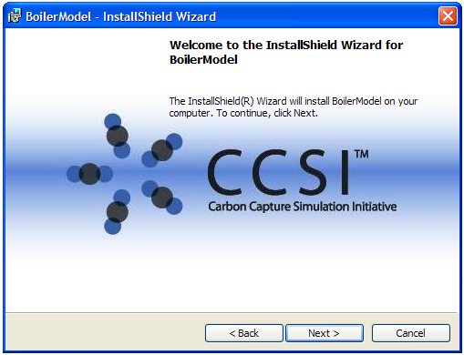

Figure : The Welcome Window of Boiler Model Installer

1. Click “Next” on the “Welcome” window to display the “License Agreement” window.
2. If the user agrees with the CCSI license terms after reading the license agreement, click “I accept” and then click “Next” to continue. The “Destination Folder” window, as shown in Figure 2, displays.

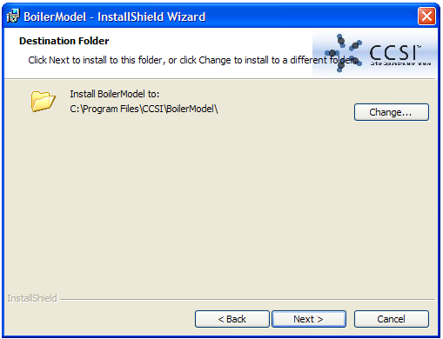

Figure : The Installer Window for Selecting Destination Folder

1. The default installation folder is “C:\Program Files\CCSI\BoilerModel”. If the operating system is a 64-bit system, the default folder is “C:\Program Files(x86)\CCSI\BoilerModel”.

Optionally, select a different folder by clicking “Change” to browse through the local file system and then select an existing folder to install the software. The “C:\Program Files\CCSI\BoilerModel” is used as the root path of the installed directory in the tutorials of this user manual. If a different installation folder is chosen, use the path of the installation folder in place of the default installation folder.

1. Click “Next” to display the “Ready to Install the Program” window, as shown in Figure 3.

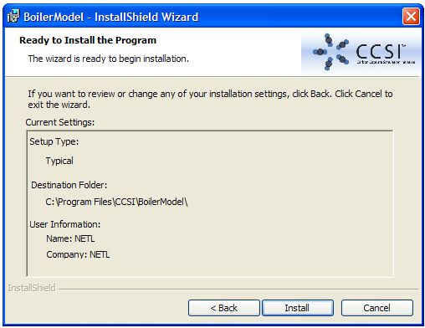

Figure : The Installer Window Indicating Ready to Install the Boiler Model

1. Click “Install” to begin the installation process. After the installation is complete, an “InstallShield Wizard Completed” window displays, as shown in Figure 4.

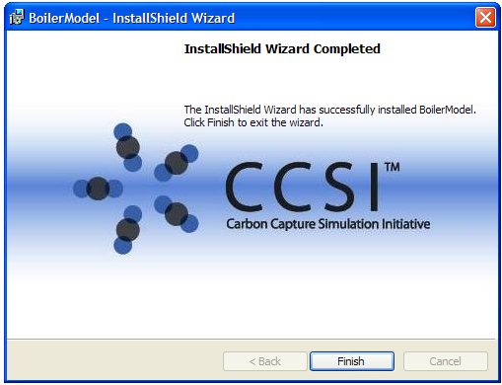

Figure : The Installer Window Showing the Installation Is Complete

1. Click “Finish” to finish the installation.
2. To confirm the correct installation, browse to the installation folder to verify that four subfolders have been created by the installer:
   1. A “Bin” folder for the executable file and DLL files
   2. A “Doc” folder for users manual and license related documents
   3. An “Examples” folder for an example to be used in the tutorial
   4. An “Image” folder for images and icons

Note: The installer does not add any link to the executable file “BoilerModel.exe” to the user’s desktop or the Windows “Start” menu. To make the Boiler Model executable command available, the path, “C:\Program Files\CCSI\BoilerModel\Bin”, needs to be added to the existing path.

The Boiler Model contains an option to create Paraview files for visualization of the simulation results in 3-D. To inspect the results in 3-D, the open source software, Paraview, needs to be downloaded and installed, according to the Paraview website: <http://www.paraview.org/download/>.

## Building a Model for an Air-Firing PC Boiler

### Description

The Boiler Model is able to model either air-firing or oxy-firing configurations. The only difference between the two configurations is the feed gas composition. The tutorial is an air-firing case. The user needs to prepare an input file that contains the input data related to the boiler design and operating conditions. This tutorial describes the required input data, the physical meaning, and the order of the data in the input file.

### Example

The example input file named, “boiler_model_input_hunter3_air.txt”, is provided in the subfolder named “Examples” under the Boiler Model’s installation directory. This example is based on PacifiCorp’s Hunter Unit 3 boiler, which was reported by Reaction Engineering International of Salt Lake City, Utah to the U.S. Department of Energy for the research contract named, “Characterization of Oxy-combustion Impacts in Existing Coal-fired Boilers” (Adams et al., 2013).

1. Copy the example input file, “boiler_model_input_hunter3_air.txt”, from, “C:\Program Files\CCSI\BoilerModel\Examples\”, to a location determined by the user. Confirm the user has write-permissions to this folder, which is the working directory.
2. Open the example input file, “boiler_model_input_hunter3_air.txt”, by any text editor such as Notepad. Review the entries, which are explained in the comments after “//” in each line of the example input file. Note: Each input takes one line and any comment after “//” is ignored by the Boiler Model. Most of the input variables are self explanatory. More detailed explanations are given below.

Line 1 contains an integer used as the flag to indicate if Paraview files should be created after the Boiler Model is solved. To enable the option, set the flag to 1; otherwise, set it to 0.

Line 2 contains an integer used as the flag to indicate if the output description file should be created. Again, use 1 to enable the option and 0 to disable the option.

Line 3 contains an integer to indicate if the mass fraction of a stream is used later in the input file. Set the integer to 1 to use mass fractions and 0 to use mole fractions.

Line 4 contains the furnace type integer related to flue gas exit plane. Set the integer to 0 if the exit plane is the vertical plane above the nose tip and 1 if the exit plane is at the top.

Line 5 contains the number of burner levels. Since the Boiler Model is a 1-D model along the furnace height for flow and reaction calculations, it requires the elevations of the feed ports as the model inputs and does not require their locations along the width or depth. The user can combine multiple burners at the same elevation to a single burner level as long as their feed stream compositions are the same. In the current version, all burner levels have to have the same feed stream composition and flow rate and so do the overfire air (OFA) levels. Each burner level has a primary feed stream that contains primary air/gas and coal, and a secondary feed stream that contains secondary air/gas only. Each OFA level contains an air/gas feed stream only with composition identical to the secondary stream of the burner levels. The flow rate specified in a later section of the input file is for a single level and hence the total flow rate is the sum of the flow rates of all levels.

Line 6 contains the number of OFA levels. For an oxy-firing case, it is the number of levels of the overfire secondary gas streams.

Lines 7, 8, and 9 contain the inputs for the spatial discretization. The Boiler Model internally assigns the hopper zone as the first zone. The burner region covers from hopper knuckle to the bottom of the nose slope. The nose region covers from the bottom of the nose slope to the tip of the nose. Finally the exit region covers from the nose tip to the roof. The user can specify the number of zones in the burner, nose and exit regions.

Lines 10 and 11 contain the numbers of cells in the depth and width directions, respectively. They are used for generating the 3-D mesh for radiation calculation. Note: The number of cells in height direction is calculated by the Boiler Model based on the number of zones and number of cells in each zone.

Starting from Line 12 (Lines 12 to 21 in this example case), the number of cells in the vertical (Y) direction in each zone is listed. Note: The total number of zones is the sum of the numbers of zones in the burner, nose, and exit regions plus 1. Therefore, the number of lines in the input file could change from case to case.

The next line (Line 22 in this example case) contains the number of panels of superheater along the width of the furnace. Boiler Model assumes that those panels are evenly spaced along the furnace width (Z direction). If there is no superheater, set this line to 0.

Line 23 contains the number of vertices of a polygon used to define the shape of the superheater panels in X-Y plane (parallel to boiler side walls). For rectangular shape, the number of vertices is 4. If there is no superheater, no entry is needed.

Line 24 contains the number of solid fuels. For this case, only one fuel is fired and 1 is entered. For coal/biomass co-firing case, enter 2.

Line 25 contains the number of size bins to describe the coal particle size distribution.

Line 26 contains the flag to indicate if the enclosure wall properties vary from zone to zone. A value of 1 indicates yes and 0 indicates no. When the value is 0, only one set of enclosure wall boundary conditions needs to be defined in the later part of the input file. If the water/steam temperature changes along height as in a supercritical unit, 1 should be entered.

Line 27 contains a flag that indicates if convective heat transfer along the boundary wall needs to be considered. Set it to 1 if yes. This line is the last line for integer inputs.

Starting from line 28, the floating point inputs are listed line by line. They have to be listed in the order described below. The number of lines for each set of input data depends on the integer inputs specified above. All variables are in SI units.

Lines 28-37 define the geometry of the boiler. The domain of the Boiler Model can be described as a solid obtained by extruding a polygon in the boiler width (Z) direction. The polygon describes the side view shape of the boiler including the hopper and the nose. Figure 5 shows the shape of the boiler along with the 3-D mesh and 1-D zones for the example.

Line 28 contains the boiler width (in Z direction).

Line 29 contains the boiler depth (in X direction).

Line 30 contains the X coordinate of the point at the bottom of the hopper on the front wall side. Note: The origin of the X-Y plane is at the intersection point of the boiler bottom plane and the front wall plane. The bottom of the model has to have certain depth, typically the depth of the ash pit opening.

Line 31 contains the X coordinate of the point at the bottom of the hopper on the rear wall side.

Line 32 contains the X coordinate of front wall at the nose tip elevation. Usually it is 0 unless the front wall is not straight up.

Line 33 contains the X coordinate of the nose tip on rear wall.

Line 34 contains the height of the boiler (Y coordinate of the roof). If the roof is sloped, the average height of the roof can be specified here.

Line 35 contains the Y coordinate of the hopper knuckle.



Figure : Boiler Volume Discretized by a 3-D Mesh and 1-D Zones

Line 36 contains the Y coordinate of the bottom of the nose slope.

Line 37 contains the Y coordinate of the nose tip.

Lines 38-43 define the locations of the 1-D zones along the furnace height (Y direction). The Y coordinate value at the top of each zone is specified if needed and used for spatial discretization. Note: The bottom of the first zone is always at the bottom of the hopper and its top is always at the hopper knuckle. The top of the uppermost burner zone is always at the bottom of the nose slope. The top of the uppermost zone of the model is always at the roof. In this case, Lines 38-42 define the top plane locations for Zones 2-6. Lines 43 defines the top plane of Zone 9. The top plane locations of Zones 1, 7, 8, and 10 are respectively the Y coordinates of the hopper knuckle, the bottom of the nose slope, the nose tip, and the nose.

Lines 45-51 define the shape of the radiant superheater panel. Since there are 4 vertices of the rectangular shape, 8 lines are needed, 2 lines (X and Y coordinates) for each vertex.

Lines 52-55 define the elevations (Y coordinates) of the 4 burner levels.

Line 56 defines the elevation of the OFA port. There is only one level in this case. Multiple lines are needed if there are more than one OFA levels.

Lines 57-78 define the coal particle size distribution for 11 size bins specified in the integer input section. For each size bin, a particle diameter and a mass fraction need to be specified.

Lines 79-92 contain the coal particle properties including the reaction kinetics.

Line 79 contains the initial coal density in the coal feed pipes. Note: The coal or char density changes in the model after moisture vaporization, devolatilization, and char reactions.

Line 80 contains the coal particle swelling factor defined as the fractional particle diameter increase during coal devolatilization.

Line 81 contains char burning mode parameter α, which relates the particle density change to the particle mass change as defined below.

$$\frac{ρ}{ρ_{0}}={\left(\frac{m_{p}}{m_{p0}}\right)}^{α}$$

where $ρ_{0}$ and $m_{p0}$ are, respectively, the particle density and mass after coal devolatilization and before the char reactions.

Line 82 contains the activation energy in the Arrhenius expression for calculating the CO/CO2 molar ratio, the ratio of the two products of char oxidation.

Line 83 contains the pre-exponential factor for the CO/CO2 ratio expression.

Line 84 contains the activation energy for the half-order char oxidation reaction.

Line 85 contains the pre-exponential factor for the half-order char oxidation reaction.

Line 86 contains the reaction order of char oxidation.

Line 87 contains the activation energy for the char gasification reaction by H2O.

Line 88 contains the pre-exponential factor for the char gasification reaction by H2O.

Line 89 contains the reaction order of char gasification by H2O.

Line 90 contains the activation energy for the char gasification reaction by CO2.

Line 91 contains the pre-exponential factor for the char gasification reaction by CO2.

Line 92 contains the reaction order of char gasification by CO2.

Note that if there are more than one solid fuels, data from Lines 57-92 need to be enter for extra solid fuels.

Lines 93-107 define the gas phase conditions of the primary feed stream for each burner level. Lines 93 and 94 define the primary stream temperature and pressure. Line 95 defines the gas stream mass flow rate for each burner level. Lines 96-107 define the mole fractions of solid C, O2, N2, H2, CO, CO2, H2O, SO2, H2S, CH4, Ar, and HCl respectively. Note: If the integer input of Line 3 is set to 1, mass fractions rather than mole fractions need to be specified here.

Lines 108-118 define the properties of coal in the primary stream. The solid phase has the same pressure and temperature as the gas phase which have already been specified in the input file. Line 108 is the particle mass flow rate for each burner level. Lines 109-116 are the mass fractions of C, H, O, N, S, Cl, moisture, and ash, respectively. They are on the “as-received” basis and should be summed up to 1. Note: The coal composition is always specified on the mass basis. Line 117 is the mass fraction of volatiles from the proximate analysis, also on the “as-received” basis. Line 118 is the high heating value of the coal on the “as-received” basis.

Lines 119-133 define the secondary stream at each burner level. The secondary stream contains the gas phase only. Lines 119-121 define the secondary stream temperature, pressure, and mass flow rate, respectively. Lines 122-133 define the mole fractions of individual species. Note: Since the example case is an air-firing case, only O2, N2, CO2, and H2O mole fractions are non-zero. Again, those fractions are mole fractions since the integer input on Line 3 is 0.

Line 134 contains the mass flow rate of each OFA level. Since there is only one OFA level in the example case, only one line of entry is needed. The temperature, pressure, and composition of the OFA stream are the same as those of the burner secondary stream.

Lines 135-137 define the boundary conditions of the enclosure wall. Since the integer input on Line 26 is 0, only one set of inputs are needed. If the integer input is 1, multiple sets of wall boundary conditions need to be specified, one set for each zone. Line 135 is the wall emissivity, which is usually related to the optical properties of the coal ash, which is usually related to coal rank. This input is the same input required by CFD models. Line 136 is the thermal resistance of the enclosure wall, which includes the thermal conduction resistances through the ash and metal layers and the convective resistance from the tube inside wall to the fluid (steam or water) inside the tube. Line 137 is the average steam/water temperature. In this case, since the boiler is a subcritical unit, the fluid is a mixture of saturated water and steam. Therefore, the saturation temperature at drum pressure is used.

Lines 138-140 define the boundary conditions of the radiant superheater wall including the wall emissivity, thermal resistance, and fluid (steam) temperature. Typically the average of the inlet and outlet steam temperatures is used.

Line 141 contains the emissivity of the vertical exit plane above the nose tip. This is usually the emissivity of the backside walls beyond the exit plane, typically around 0.7. To avoid too high radiation leakage to the backside surface beyond the exit plane, a small number (0.1 in this case) is used.

Line 142 contains the temperature of the surfaces beyond the exit plane, which is needed for the radiation boundary condition of the exit plane. Typically the wall temperature of the convective superheater downstream of the exit plane is used here.

Line 143 contains the effectiveness factor for gas absorption coefficient, which is a tuning factor applied to the gas absorption coefficient to consider the effect of non-uniform distribution of temperatures and compositions in individual zones on the radiation heat transfer. Likewise, Line 144 contains the effectiveness factor for particle absorption coefficient. It needs to be mentioned that more research work needs to be performed to provide the guidelines for selecting those effectiveness factors. Preliminary validation work found that for large-scale boilers burning high-volatile bituminous coal, the effectiveness factor of 1 could be used for the two parameters.

Lines 145-154 contain the effectiveness factors for the char reaction kinetics, which is related to the “mixedness” of the solid and gas reactants in all zones.

1. The command can now be used to solve the Boiler Model. Open a DOS command window from “Start” in Windows. In the DOS command window, change the directory to the working directory. Type “BoilerModel –i boiler_model_input_  
   hunter3_air.txt –o boiler_model_output_hunter3_air.txt” as the command in the DOS window. The “-i” option is for specifying the name of the input file and the “-o” option is for specifying the name of the output file. Note: If the options are not entered as command line parameters, the default file names, “boiler_model_input.txt” and “boiler_model_output.txt” are used as defaults. During the execution of the “BoilerModel” command, some messages are displayed in the DOS window, such as the maximum temperature change during the iteration and the number of iterations used to converge the model. Note: If the flags inside the input file for the creation of Paraview files and result description file are turned on, the corresponding output files are written to the working directory. The Paraview file names are “boiler_model.vtk” and “boiler_model_bnd.vtk”. The output description file contains the description string for each variable in the output file. The name of the description file is “boiler_model_output_description.txt”.
2. Open the output file to examine the simulation results. A best practice is to turn on the flag in the input file to indicate to the Boiler Model to write the output description file. The output variables and the description strings in the output description file are listed one row at a time.
3. Optionally, the simulation results can be visualized using Paraview. Please visit the Paraview website ([www.paraview.com](http://www.paraview.com/)) to learn more of its use. With Paraview, the properties in each zone (e.g., temperature, CO and O2 mole fractions, and gas emissivity) and the properties in each boundary faces (e.g., heat flux and wall temperature) can be examined.

# Usage Information

## Support

To obtain support for this package, please send an email to   
[ccsi-support@acceleratecarboncapture.org](mailto:ccsi-support@acceleratecarboncapture.org), and/or complete the “Submit Feedback/Request Support” form available on the product distribution page.

## Restrictions

The Boiler Model solves the flow, reactions, and heat transfer equations numerically. Usually the convergence can be reached within 100 iterations. If the Boiler Model does not reach the convergence within 100 iterations, it exits with a warning message. If the user inputs are inappropriate, the model may also fail to reach a converged solution.

# Debugging

The DOS window displays messages regarding solving processes, which could help in debugging.

## How to Debug

Mistakes made by a user in the input file can usually be caught by the Boiler Model with warning messages.

## Reporting Issues

To report an issue, please send an email to [ccsi-support@acceleratecarboncapture.org](mailto:ccsi-support@acceleratecarboncapture.org).

# Reference

Adams, B.R., David, K., Senior, C., Shim, H.S., Otten, B.V., Fry, A., Wendt, J., Eddings, E., Paschedag, A., Zurek, S., Shaddix, C., and Cox, W., “Characterization of Oxy-Combustion Impacts in Existing Coal-Fired Boilers,” Final Technical Report, NT0005288, 2013.